ExNo:26 <!--INLINE CSS-->

PROGRAM:

<html>

<title>inline css</title>

<body>

<p style="color:yellow;background-color:red; height:120;font-size:18">

<b><i> I LEARNED SOMETHING IN HTML</b></i></p>

</body>

</html>

OUTPUT:

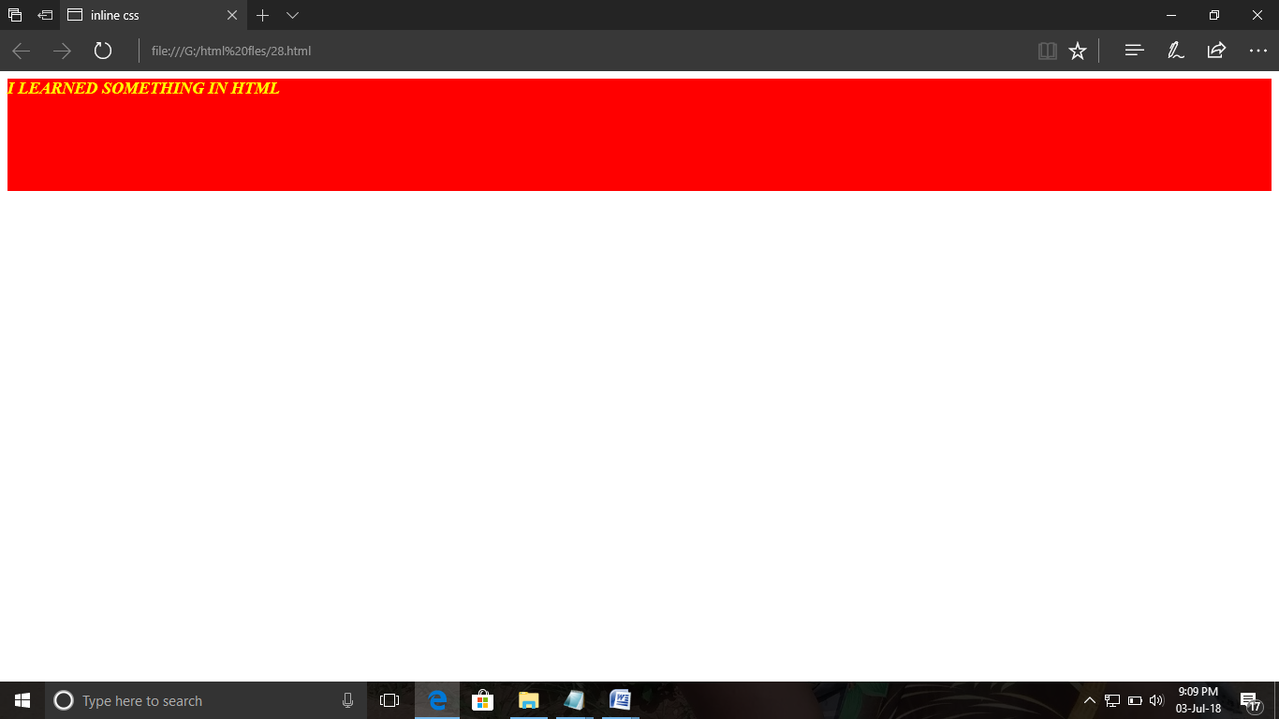

ExNo:27 <!--CSS BACKGROUND-->

PROGARM:

<html>

<title>css background</title>

<body>

<p style=" background-color:red; height:1000;font-size:18;text-align:center">

<b><i> I WILL BECOME A ENGINEER</b></i></p>

</body>

</html>

OUTPUT:

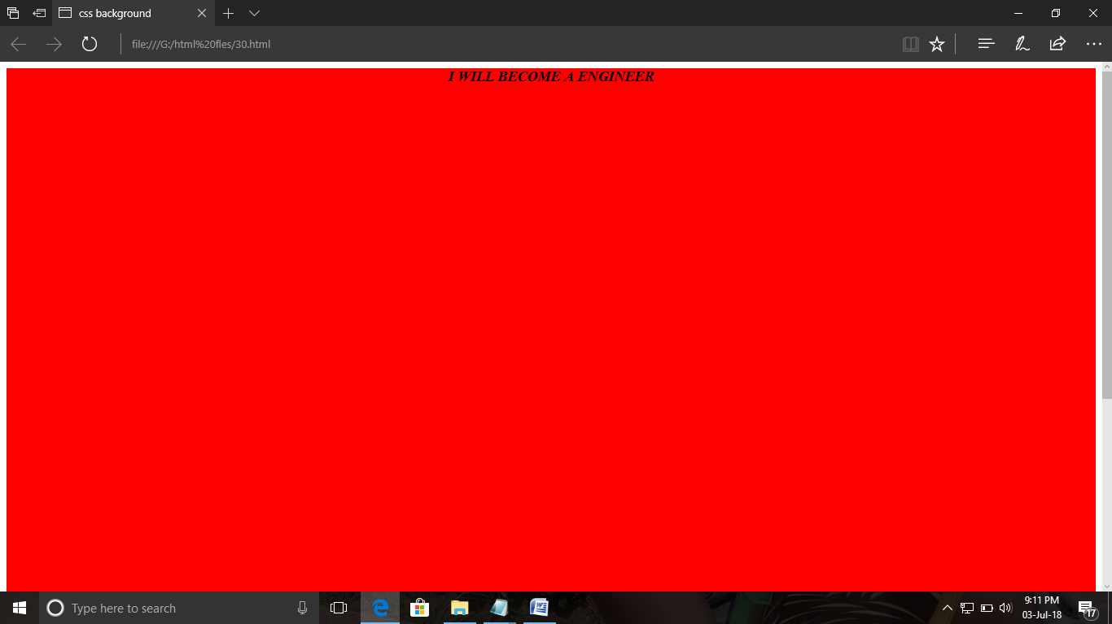

ExNo:28 <!--CSS FONT-->

PROGRAM:

<html>

<title>css font</title>

<body>

<p style="font-family:Castellar;font-size:18;text-align:center">

<b><i>ENGINEERING IS MY DREAM</b></i></p>

</body>

</html>

OUTPUT:

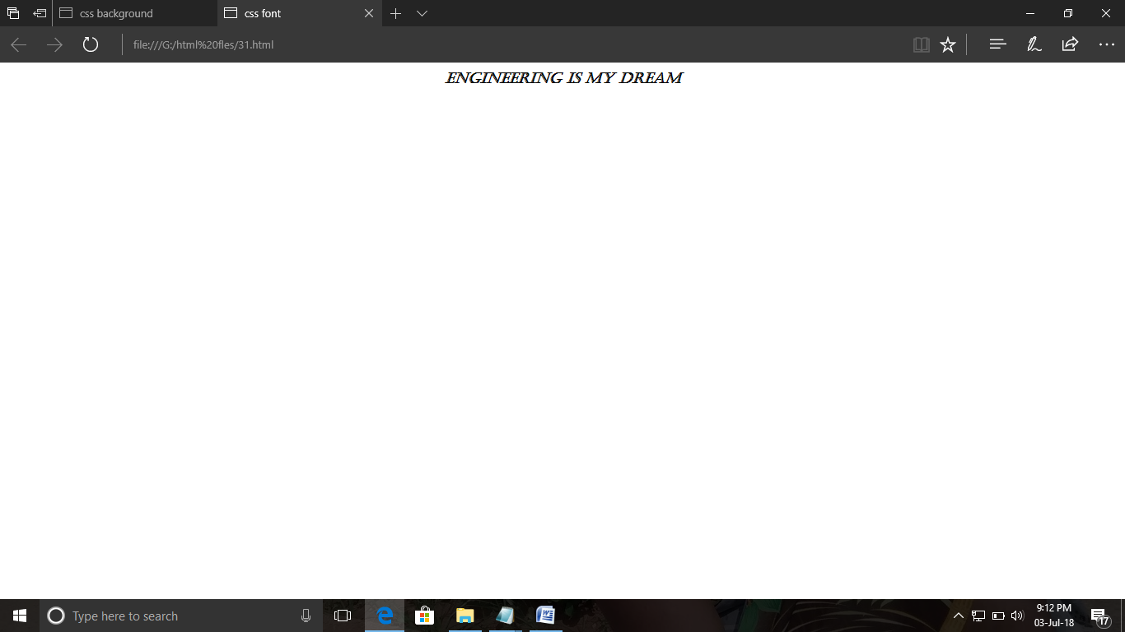

ExNo:29 <!--CSS TEXT-->

PROGRAM:

<html>

<title>css text</title>

<body style=" background-color:green;text-align:center">

<p><u>I M DOING CSS TEXT PROGRAM</u></p>

</body>

</html>

OUTPUT:

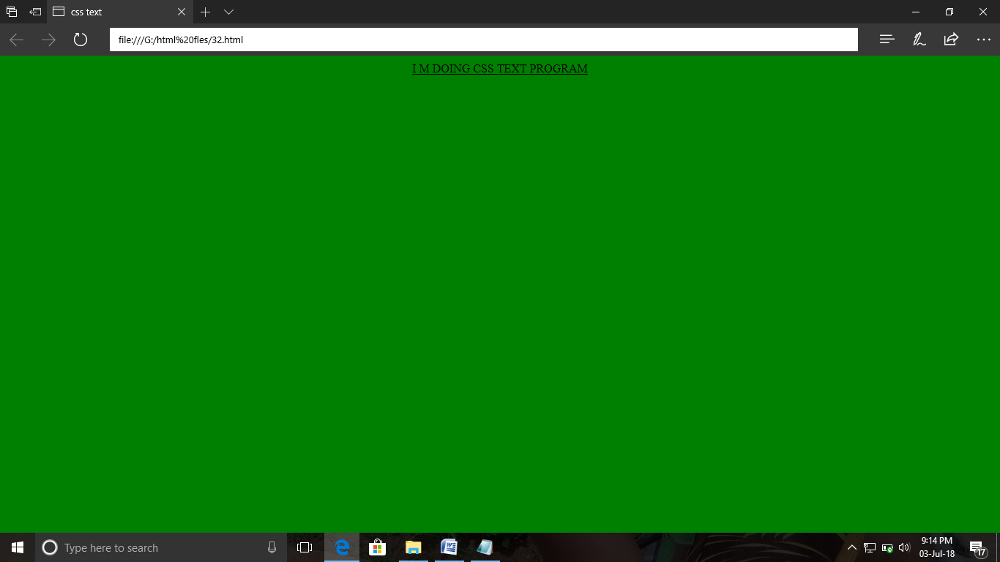

ExNo:30 <!--CSS PDDING-->

PROGRAM:

<html>

<title>cell padding</title>

<head>

<style>

p{

padding:52px;

color:orange;}

</style>

</head>

<body>

<p><b>MY FATHER IS A DRIVER</b></p>

</body>

</html>

OUTPUT:

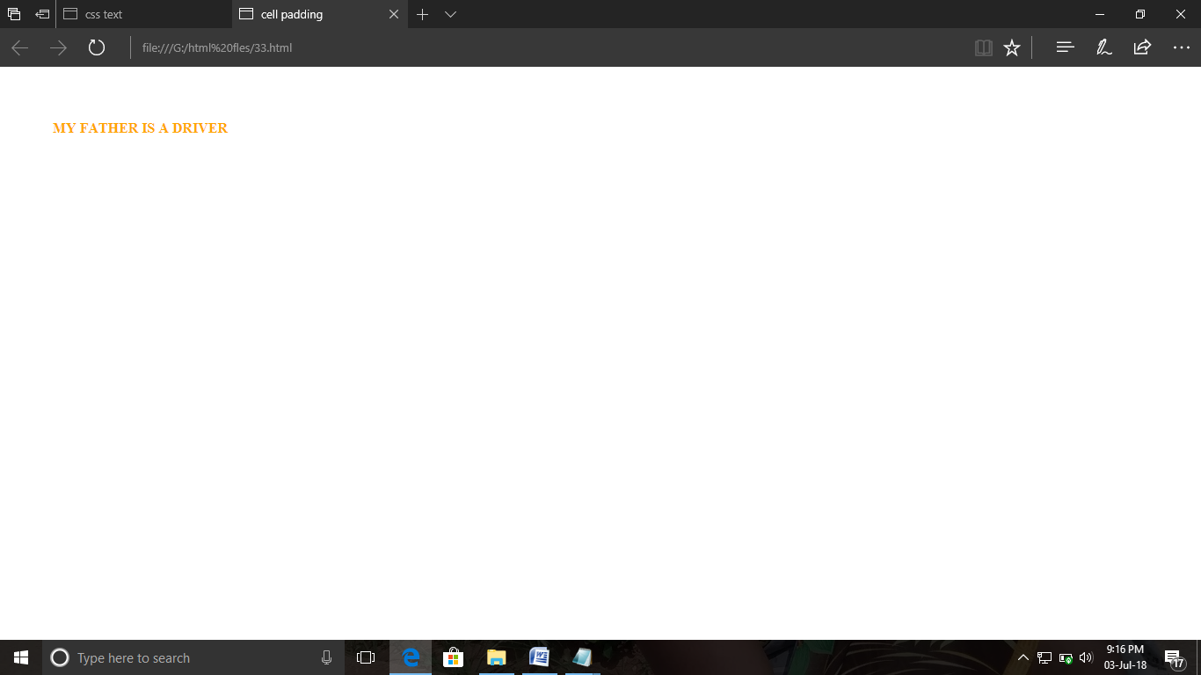

ExNo:31 <!--CSS MARGIN-->

PROGRAM:

<html>

<title>css padding</title>

<head>

<style>

p{

background-color:red;

margin: 10px 25px 32px 400px;}

</style>

</head>

<body>

<p>M.SREE DINESH KUMAR</p>

</body>

</html>

OUTPUT:

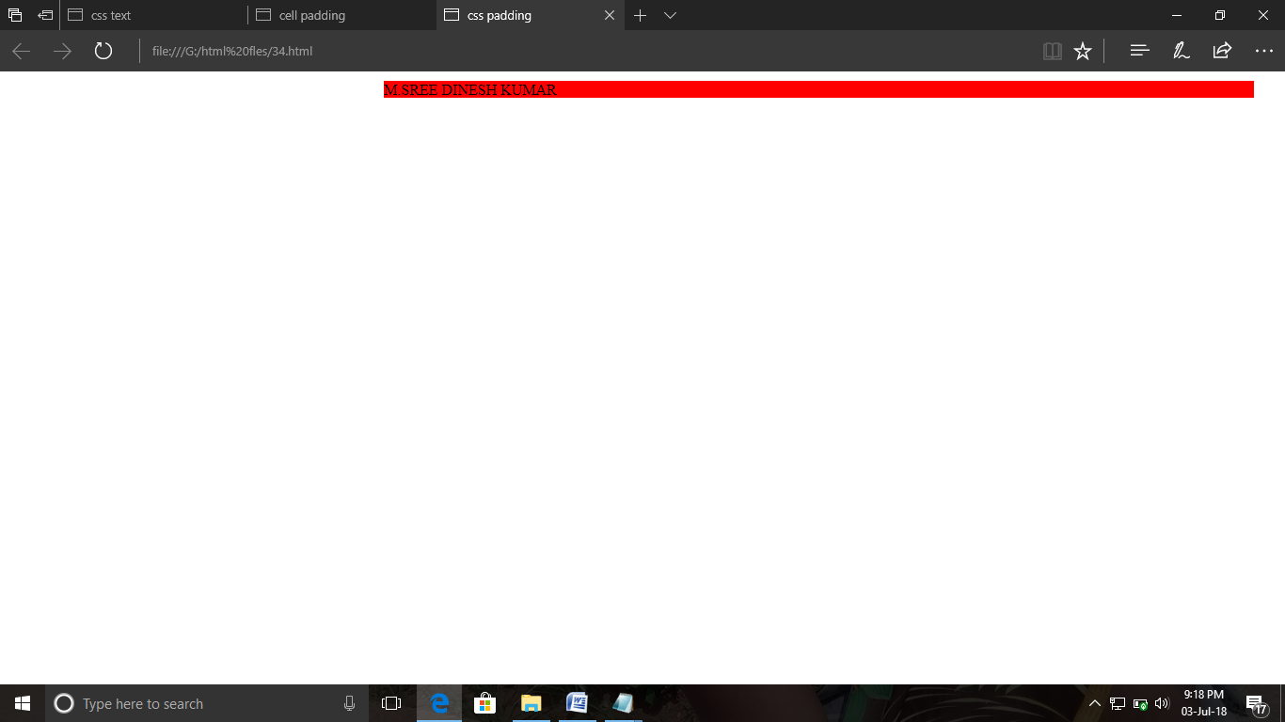

ExNo:32 <!--CSS BORDER MARGIN-->

PROGRAM:

<html>

<title>css border margin</title>

<head>

<style>

p.a1

{

outline-style:dotted;

outline-color:green;

}

p.a2

{

outline-style:dashed;

outline-color:red;

}

</style>

</head>

<body>

<p class="a1"> dineshkumar</p>

<p class="a2"> santhoshkumar</p>

</body>

</html>

OUTPUT:

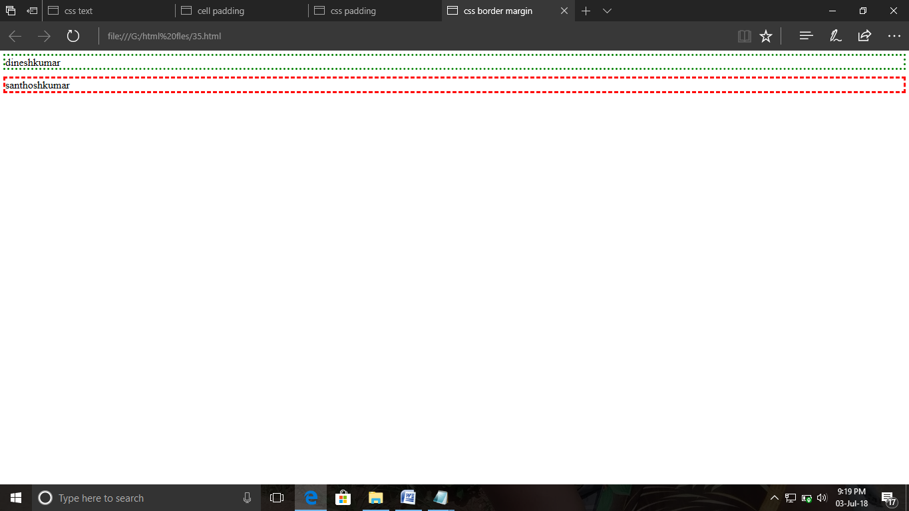

ExNo:33 <!--CSS LIST-->

PROGRAM:

<html>

<title>css list</title>

<head>

<style>

ul.a

{

list-style-type:circle;

}

ol.b

{

list-style-type:upper-roman;

</style>

</head>

<body>

<p>unordered list</p>

<ul class="a">

<li>dineshmurugan</li>

<li>santhoshkumar </li>

<li>parameshwari</li>

</ul>

<p>ordered list</p>

<ol class="b">

<li>dineshmurugan</li>

<li>santhoshkumar </li>

<li>parameshwari</li>

</ol>

</body>

</html>

OUTPUT:

